A.8.5 – Graphing in Factored Form: Intercept Heist

DO NOW STATION CIRCUIT
Rotate through each station. Answer the questions clearly.

Station 1 – Vertex Form Recall
Equation:
Vertex | Opens open or down

Station 2 – Standard Form Recall
Equation:
x-coordinate of vertex $\frac{-b}{2a}$ | y-value of vertex (plug the x value into the equation)

Station 3 – Pattern Spotting
Equation:
x − 3 = 0 → x = ______ | x + 1 = 0 → x = ______
These x-values represent:

Station 4 – Intercepts Investigation
Equation:
Zeros: | Intercepts (x, y):
Where might the vertex be?

MAIN ACTIVITY – Intercept Heist

Zeros: | Intercepts (x, y):
Opens Up or Down: | Axis of Symmetry:
Sketch below:
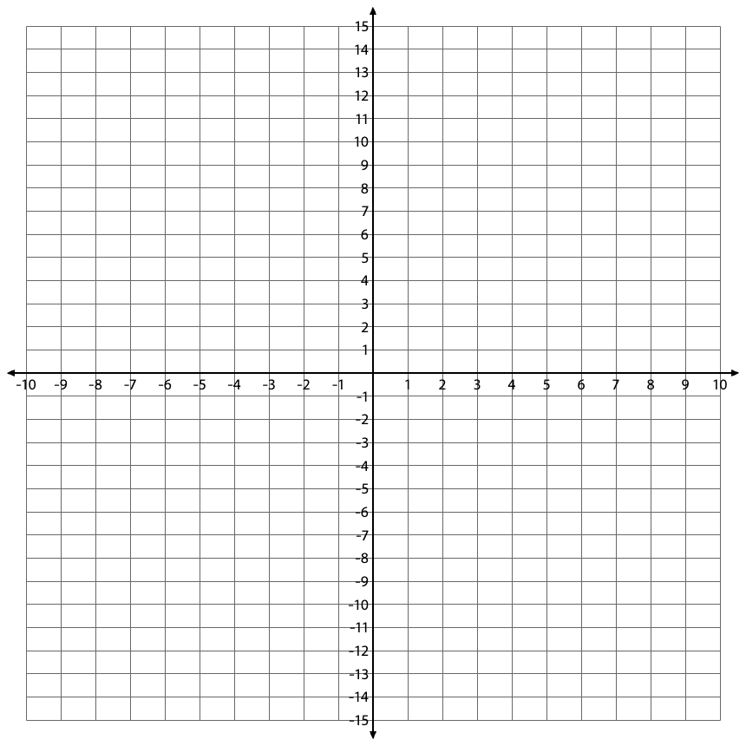

Zeros: | Intercepts (x, y):
Opens Up or Down: | Axis of Symmetry:
Sketch below:

Zeros: | Intercepts (x, y):
Opens Up or Down: | Axis of Symmetry:
Sketch below:

Zeros: | Intercepts (x, y):
Opens Up or Down: | Axis of Symmetry:
Sketch below:

CHALLENGE – Form Switch
$y=x^{2}-4x-12$
Factor: | Zeros
Sketch:

$y=x^{2}-4x-12$
Factor: | Zeros
Sketch:

